-Aindrila Datta

**Table Of Contents:**

Abstract-------------------------------------------------------------------------------1

Block Diagram-----------------------------------------------------------------------2

Components Description---------------------------------------------------------3

High Level Requirements--------------------------------------------------------3

Low Level Requirements---------------------------------------------------------4

SWOT Analysis---------------------------------------------------------------------4

Applications--------------------------------------------------------------------------5

**Abstract:**

Microcontroller based Temperature Controller uses LM35 Temperature Sensor for measurement of temperature and 16x2 LCD is used to display temperature set point, Heater Status and current temperature, It controls temperature by turning on and off of the heater using relay.  
  
This project is very useful for controlling of temperature, It can be used for soldering station to make it automatic temperature controlled.

Temperature control refers to the processes that are aimed at maintaining the temperature in a given area at certain maximum/minimum level or within a certain range. This process is commonly used in most areas of the world. Recently, globalization and industrialization has further necessitated the need for Temperature Control applications in various daily activities, especially with the advent of the greenhouse effect. Many Homes and Industries among other areas maintain certain sections of operation that must be maintained within a certain temperature for process to work successfully. In research laboratories, the lack of use of Temperature Control Systems has led to the purchase of chambers of various sizes where temperature specific research work would be kept. This has also led to an increase in overhead cost. In areas that have electronic activities or machinery functioning constantly, such as in server rooms and production plants. These are places where heavy machinery and computers work continuously 24 hours every day. During these processes, the temperature needs to be monitored frequently.

that it doesn’t rise or fall below a value that would accelerate wearing out of the systems.

**Block Diagram:**

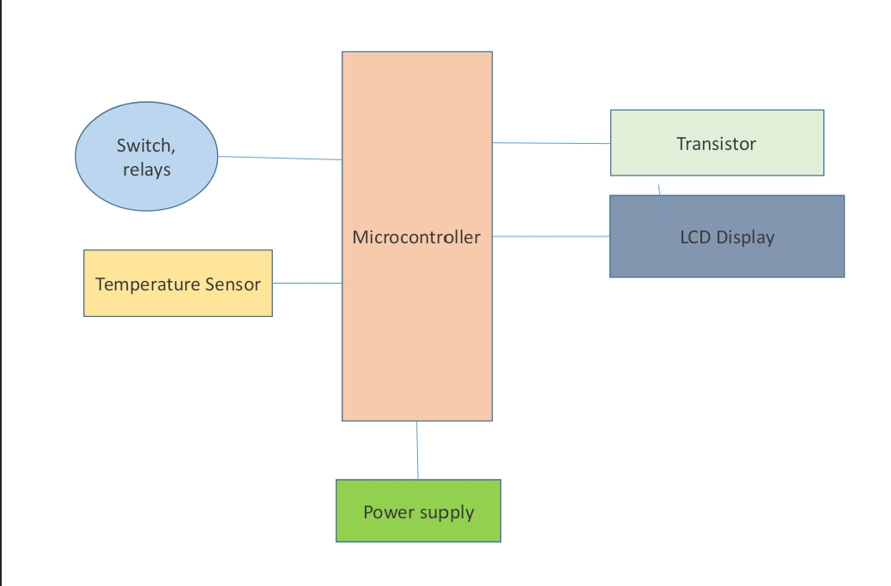

**Components Description:**

* ATMega 8 Microcontroller:

It is a low -power CMOS 8-bit microcontroller based on the AVR RISC architecture. By executing powerful instructions in a single clock cycle, the ATMega8 achieves throughputs approaching 1 MIPS per MHz, allowing the system designer to optimize power consumption.

* Here is the Pin Description :
* LM35 Temperature Sensor:

It outputs an analogue signal which is proportional to the instantaneous temperature. The output voltage can easily be interpreted to obtain a temperature reading in Celsius. The advantage of LM35 over thermistor is that it does not require any external calibration.

* Relay:

It is one of the most important electromechanical devices highly used in industrial applications mostly automations. A relay is used for electrical to electronic interfacing i.e., it is used to switch on or off electrical circuits operating at high A.C. voltage using a low D.C. control voltage.

* LCD Display:

It is a flat panel display, electronic visual display, or video

display that uses the light modulating properties of liquid crystals.

* BC548:

A transistor used for amplifying & switching purposes in electrical circuits.

**High Level Requirements**:

* Temperature controllers are needed in any situation (where an object is required to be heated, cooled or both to remain at the setpoint regardless of the changing environment around it) requiring a given temperature be kept stable.
* Ensures maintaining of thermal comfort by monitoring the temperature of the environment.

**Low Level Requirements:**

* Automatically controls the temperature of the environment it is placed in by the timely activation of the effector devices to influence the temperature in relation to the set point.

**SWOT Analysis:**

Strengths:

* Eliminates human error that can occur with attempting to control temperatures manually.
* Saves time, minimizes cost, and automates the process from start to finish.
* User-friendly, efficient, and accurate.

Weakness:

* Electrical supply required.
* More complex than self-acting or pneumatic controls.

Opportunities:

* This type of embedded systems can also be implemented in industries, automobiles, etc.
* It is a very common type of embedded system implemented in different systems like air conditioning, water heaters, refrigerators, etc.

Threats:

* Oxidized and hydrolysed components that are toxic.
* Loss of therapeutic cycles caused by freeze-thaw cycles.

**Applications:**

Temperature controllers are used in a wide variety of industries to manage manufacturing processes or operations. Some common uses for temperature controllers in industry include plastic extrusion and injection moulding machines, thermo-forming machines, packaging machines, food processing, food storage, and blood banks. The following is a brief overview of some common temperature control applications in industry:

* **Heat Treat/Oven**

Temperature controllers are used in ovens and in heat-treating applications within furnaces, ceramic kilns, boilers, and heat exchangers.

* **Packaging**

In the packaging world, machinery equipped with seal bars, glue applicators, hot melt functions, shrink wrap tunnels or label applicators must operate at designated temperatures and process time lengths. Temperature controllers precisely regulate these operations to ensure a high quality product output.

* **Plastics**

Temperature control in the plastics industry is common on portable chillers, hoppers and dryers and molding and extruding equipment. In extruding equipment, temperature controllers are used to precisely monitor and control temperatures at different critical points in the production of plastic.

* **Healthcare**

Temperature controllers are used in the healthcare industry to increase the accuracy of temperature control. Common equipment using temperature controllers includes laboratory and test equipment, autoclaves, incubators, refrigeration equipment, and crystallization growing chambers and test chambers where specimens must be kept or tests must be run within specific temperature parameters.

* **Food & Beverage**

Common food processing applications involving temperature controllers include brewing, blending, sterilization, and cooking and baking ovens. Controllers regulate temperature and/or process time to ensure optimum performance.